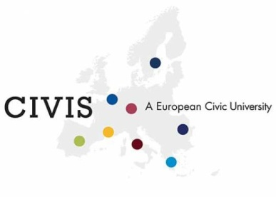
Higher Education
Erasmus+ CIVIS
Certificate of Attendance

Student Last Name |  | First Name
Date of Birth |  | Home Institution (Erasmus code)
Host Institution (Erasmus code)
Faculty/ Department
ACADEMIC RESPONSIBLE:
 | Tel: |  | e-mail:

START AND END DATES OF PHYSICAL MOBILITY | FROM [DAY/MONTH/YEAR] _______________TILL [DAY/MONTH/YEAR]_______________

PROJECT TITLE:

FULL LIST OF ACTIVITIES WITHIN THE PROJECT (including physical and online activities):

EXAMPLE:
Online courses on…
Lecture on Meditteranean transmodernities (Marseille, 8/6/2021)
Roundtable on European imperialism and race, Mediterranean modernities, spatiality and borders, de/monumentalisation in Europe (Marseille, 9/6/2021)
Workshop on multiple modernities, European avant-gardes, and peripheral cultural communities (Marseille, 10/6/2021)
Workshop on transnational modernism and methodological nationalisms, public spaces and monuments, spatiality and borders (Marseille, 11/6/2021)

METHOD OF EVALUATION (if applicable):

EXAMPLE:
Response Paper (circa 1,500wds): 20%
Participation and attendance: 20%
Research Paper (up to 2,500): 45%
Oral presentation: 15%

GRADE(S)/MARKS (if applicable):

LEARNING OUTCOMES:

EXAMPLE:
The participation in the project aimed to deepen the student’s critical skills through active participation in its seminars and roundtables, as well as visits to local cultural institutions. Moreover, students have applied research methodologies and theoretical frameworks to a wide variety of issues across national cultural and political boundaries.

TOTAL DURATION OF PROJECT’S ACTIVITIES | FROM [DAY/MONTH/YEAR] _______________TILL [DAY/MONTH/YEAR]_______________ | ECTS CREDITS AWARDED  (if applicable)
WORKLOAD IN HOURS | TOTAL DURATION OF THE PROJECT (IN HOURS): X HOURS  TOTAL OF HOURS GUIDED BY THE PROFESSOR: X HOURS

 | Date
Signature | Institution’ s Stamp:
PROJECT COORDINATOR

