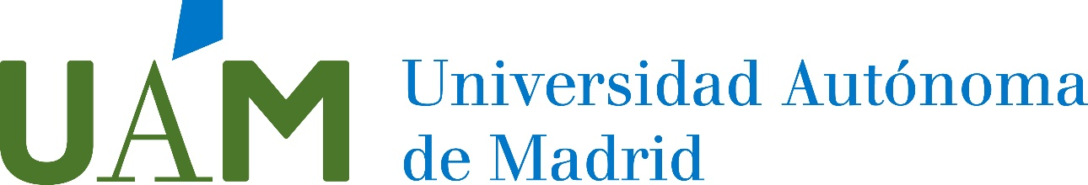

CENTRO DE FORMACIÓN CONTINUA

APPLICATION FORM

Study Abroad at UAM Academic Programs

PASSPORT FAMILY NAME FIRST NAME  BIRTH DATE PLACE OF BIRTH STATE OF BIRTH COUNTRY OF BIRTH  ADDRESS ZIP CODE CITY  STATE NATIONALITY TELEPHONE NUMBER  E-MAIL  GENDER MALE FEMALE  MAXIMUM ACADEMIC DEGREE (High School, Undergraduate, Graduate, Master, PhD, Engineer)  UNIVERSITY / CENTER COUNTRY |  | STUDENT INFORMATION

Course you are applying for:
☐ Español para Extranjeros (13th June – 1th July, 2022)

☐ Brush-up on your Spanish (22th August – 2th September, 2022)

☐ Survival Spanish (22th August – 2th September, 2022)

Date: Signature:

CHECKLIST AND ADDITIONAL INFORMATION:
To complete your application you must send the following documents to studyabroad@uam.es .

☐ A scanned copy of your passport/photo ID page or an EU Citizen National ID card for European students.
☐ A scanned copy of the proof of language ability.

